33.39: Note: The radius is reduced by a factor of two since the beam must be incident at 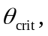 then reflect on the glass-air interface to create the ring.

